Git & GitHub Task Completion Document
Candidate Name | Mohammed Abdul Nayeem
Date | 20-Aug-2026
GitHub Repository | ____________________________________________
GitHub Username | ____________________________________________
Environment | Local machine / Linux or macOS

1. Objective
The objective is to demonstrate practical Git and GitHub skills including repository creation, local cloning, branching, commits, push/pull workflows, pull requests, .gitignore usage, SSH authentication, webhooks, Git internals, logs, commit modification, reset, revert, stash and commit squashing.

2. Prerequisites
- A GitHub account with permission to create repositories.
- Git installed on the local machine.
- A terminal such as Linux/macOS Terminal, Windows PowerShell, Git Bash or equivalent.
- A text editor or IDE.
- For SSH/webhook tasks, access to the relevant GitHub repository settings.
- For Task 18, a reachable webhook receiver URL (for example, a test endpoint or an approved DevOps integration endpoint).

3. Suggested Repository
Repository name: git-github-practical
Local directory: ~/git-github-practical
Default branch: main (GitHub commonly uses 'main'; use 'master' only if your repository is configured that way).

Task 1. Install Git
Purpose: Install Git and verify that it is available from the command line.

Steps
- Install Git using the operating-system package manager or the official installer.
- Open a new terminal after installation.
- Verify the installed version.

Commands / Actions
# Ubuntu/Debian
sudo apt update && sudo apt install -y git
git --version

Expected Result
The terminal displays the installed Git version, for example: git version 2.x.x.
Evidence / Screenshot:
- Screenshot of `git --version` output.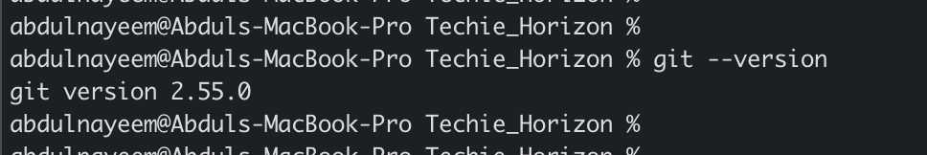

Task 2. Create a GitHub Repository with README.md and .gitignore
Purpose: Create the central repository and initialize it with a README and ignore rules.

Steps
- Sign in to GitHub.
- Create a new repository named `git-github-practical`.
- Select the option to add a README file.
- Select an appropriate `.gitignore` template, or create a blank `.gitignore` and update it later.
- Create the repository.

Commands / Actions
GitHub UI: New repository → Repository name → Add README → Add .gitignore → Create repository.

Expected Result
The GitHub repository contains at least `README.md` and `.gitignore`.
Evidence / Screenshot:
- Evidence: Screenshot of the GitHub repository root showing `README.md` and `.gitignore`.
- Evidence: Screenshot of the repository URL/address bar.
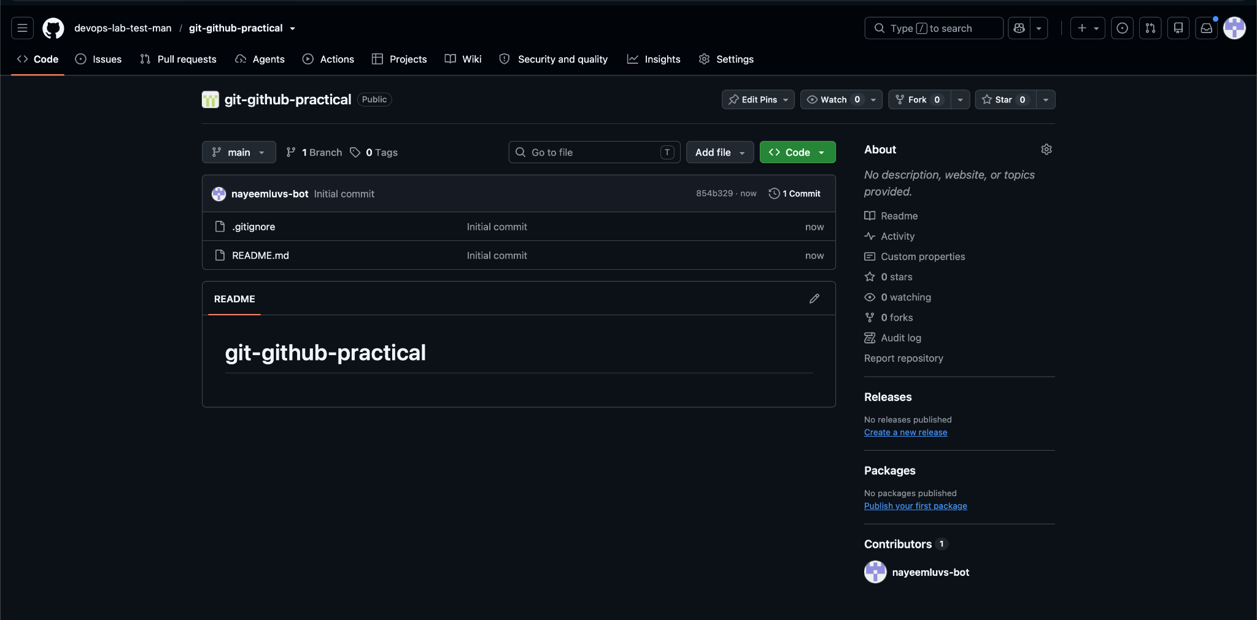

Task 3. Clone the Created Repository to Local
Purpose: Create a local working copy of the central repository.

Steps
- Copy the HTTPS or SSH clone URL from GitHub.
- Open a terminal in the desired parent directory.
- Clone the repository and enter the directory.
- Confirm the remote configuration.

Commands / Actions
git clone git@github.com:devops-lab-test-man/git-github-practical.git
cd git-github-practical
git remote -v

Expected Result
The repository is downloaded locally and `origin` points to the GitHub repository.
Evidence / Screenshot:
- Evidence: Screenshot showing successful `git clone` output.
- Evidence: Screenshot of `git remote -v`.
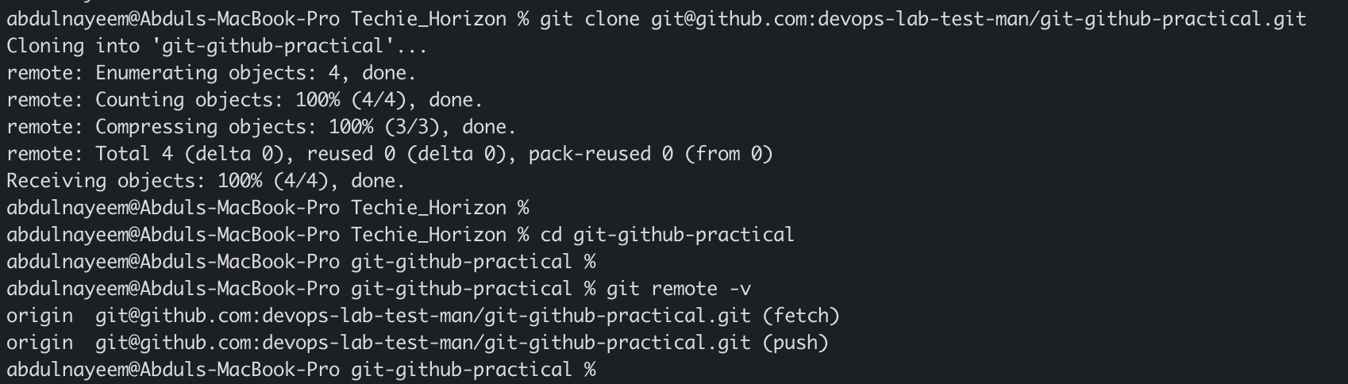

Task 4. Create Two Files in the Local Repository
Purpose: Create two tracked candidat e files in the cloned working directory.

Steps
- Ensure you are inside the repository directory.
- Create `file1.txt` and `file2.txt`.
- Add simple content to each file.
- Check repository status.

Commands / Actions
printf 'Git practice file 1\n' > file1.txt
printf 'Git practice file 2\n' > file2.txt
git status

Expected Result
Git reports the two new files as untracked.
Evidence / Screenshot:
- Evidence: Screenshot of the terminal showing `git status` with `file1.txt` and `file2.txt`.
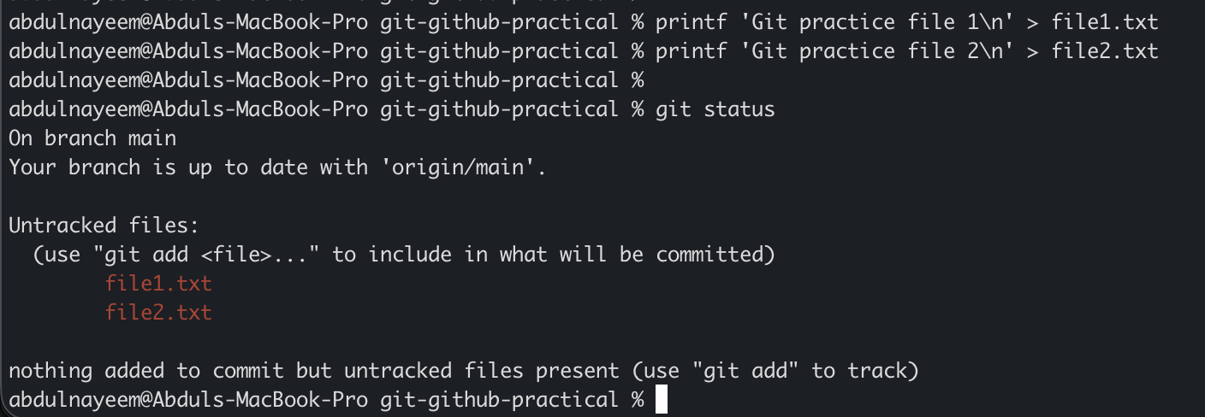

Task 5. Commit Two Files and Push to Central Repository
Purpose: Stage, commit and upload the two local files to GitHub.

Steps
- Stage both files.
- Create a meaningful commit message.
- Push the commit to the default branch.
- Refresh GitHub and verify both files are present.

Commands / Actions
git add file1.txt file2.txt
git commit -m "Adding two txt files"
git push origin main

Expected Result
The commit is created locally and pushed successfully to GitHub.
Evidence / Screenshot:
- Evidence: Screenshot of `git commit` output.
- Evidence: Screenshot of successful `git push` output.
- Evidence: Screenshot of GitHub showing the two files.
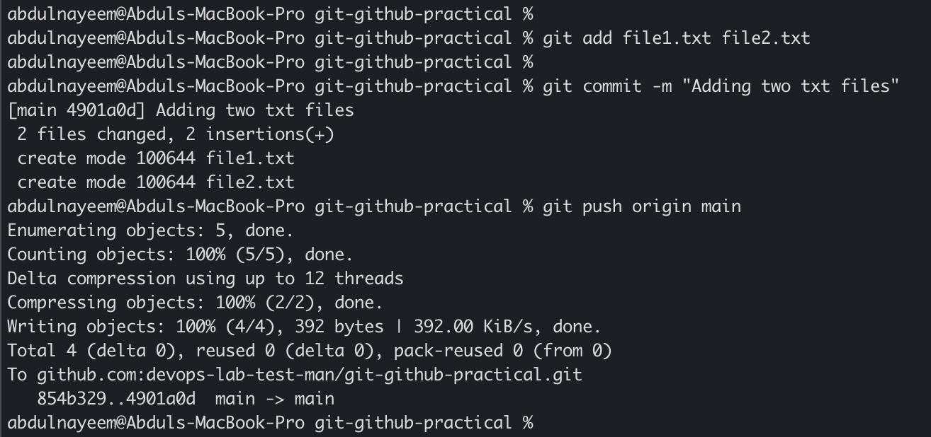

Task 6. Create a Local Branch, Add a Sample File and Push It
Purpose: Demonstrate feature-branch creation and publishing to GitHub.

Steps
- Create and switch to a branch named `feature-local`.
- Create a sample file and add content.
- Commit the file.
- Push the branch and set its upstream.

Commands / Actions
git switch -c feature-local
printf 'Sample change from local branch\n' > local-branch.txt
git add local-branch.txt
git commit -m "Adding file from local branch"
git push -u origin feature-local

Expected Result
GitHub displays the newly pushed `feature-local` branch and its file.
Evidence / Screenshot:
- Evidence: Screenshot of `git branch`/`git status` showing `feature-local`.
- Evidence: Screenshot of successful branch push.
- Evidence: Screenshot of the branch on GitHub.
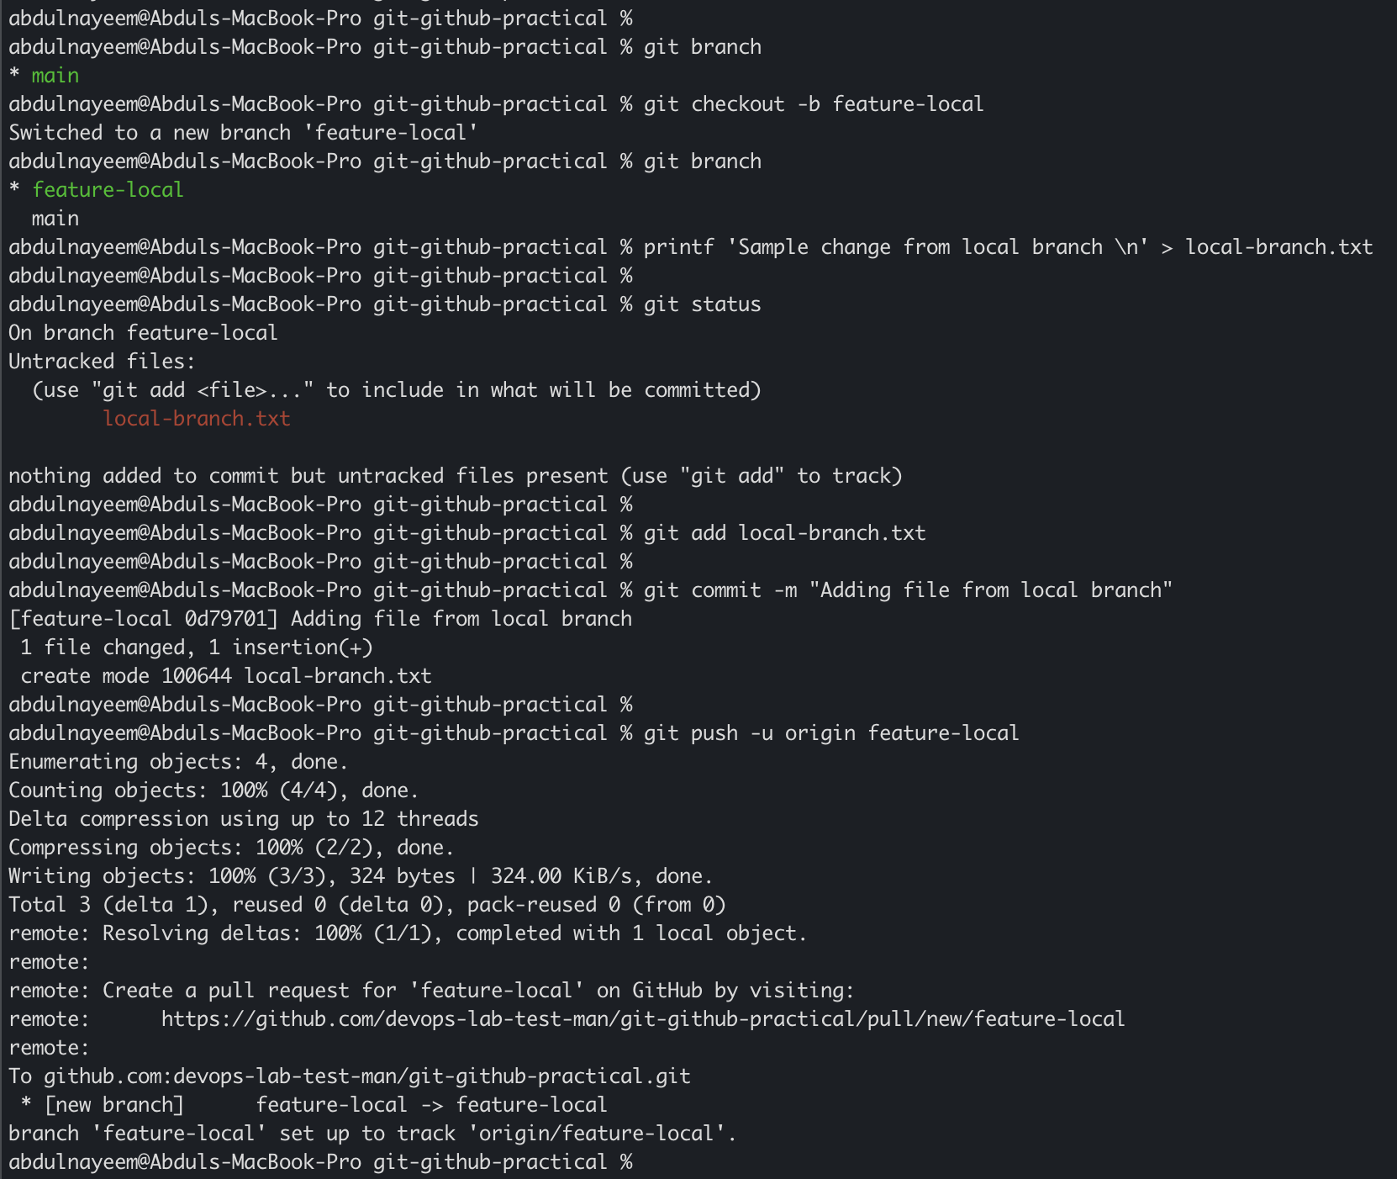
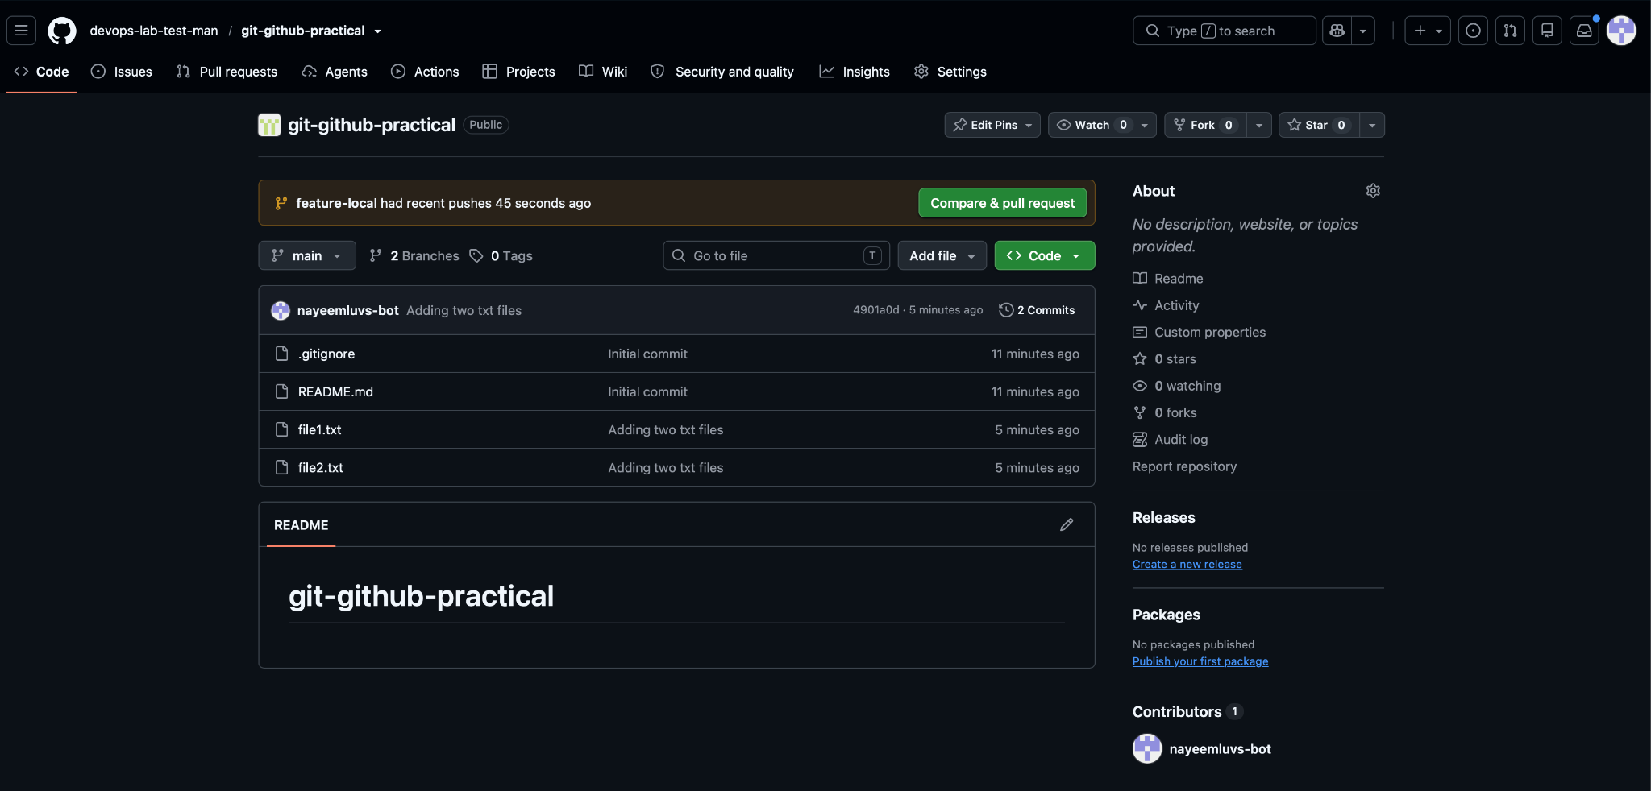
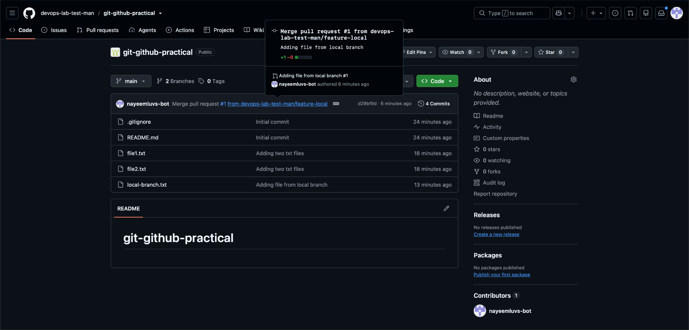

Task 7. Create a Branch in GitHub and Clone That Branch Locally
Purpose: Create a branch on GitHub first and then retrieve it locally.

Steps
- On GitHub, open the repository and create a branch named `feature-github` from `main`.
- Fetch remote branch information locally.
- Create a local tracking branch for `feature-github`.
- Verify the active branch.

Commands / Actions
git fetch origin
git switch --track -c feature-github origin/feature-github
git branch -vv

Expected Result
The local `feature-github` branch tracks `origin/feature-github`.
Evidence / Screenshot: Attach the relevant screenshot(s) showing the command/output or GitHub UI result.
- Evidence: Screenshot of GitHub showing `feature-github`.
- Evidence: Screenshot of local `git branch -vv`.
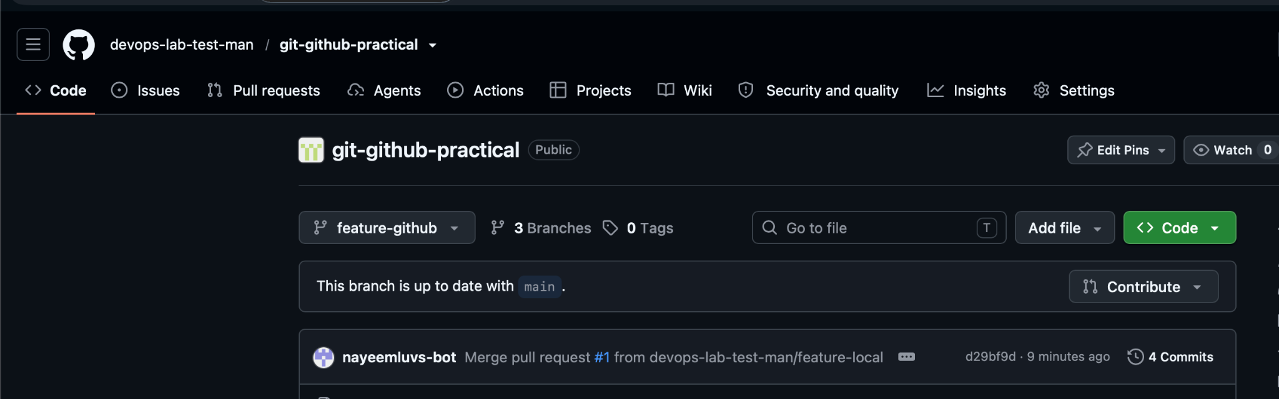
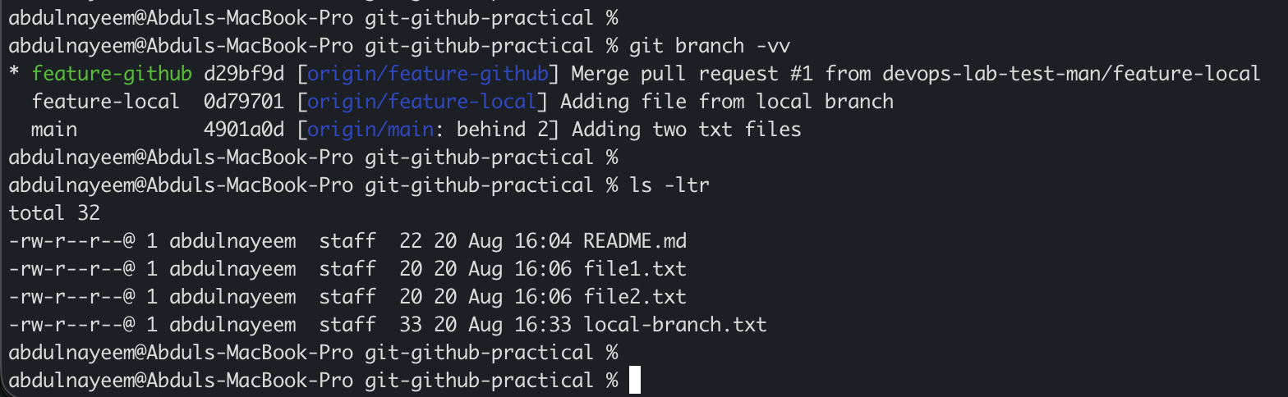

Task 8. Merge the Created Branch with Main in Local Git
Purpose: Merge a feature branch into the local default branch.

Steps
- Switch to the local `main` branch.
- Update it from the remote repository.
- Merge `feature-local` into `main`.
- Verify the resulting history and status.

Commands / Actions
git switch main
git pull origin main
git merge feature-local
git status
git log --oneline --graph --decorate -10

Expected Result
The feature branch changes are present in local `main`.
Evidence / Screenshot: Attach the relevant screenshot(s) showing the command/output or GitHub UI result.
- Evidence: Screenshot of merge output.
- Evidence: Screenshot of `git log --oneline --graph`.
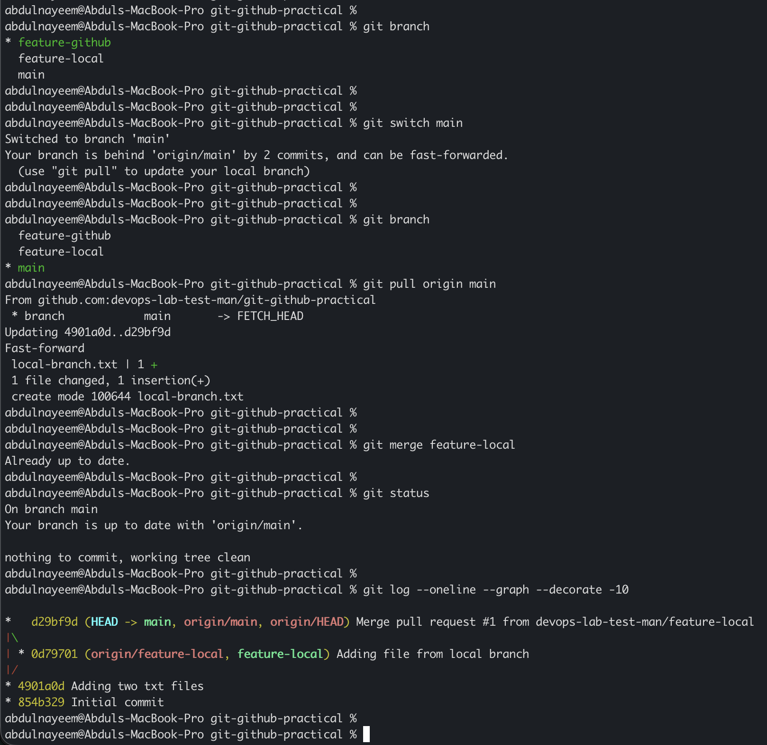

Task 9. Merge the Branch with Main in GitHub Using a Pull Request
Purpose: Demonstrate GitHub-based code review and branch integration.

Steps
- Push the branch if it is not already on GitHub.
- Open GitHub and select the feature branch.
- Create a Pull Request targeting `main`.
- Add a title and description, review the changes and merge the PR.
- Delete the branch if permitted by your workflow.

Commands / Actions
git push -u origin feature-github
GitHub UI: Pull requests → New pull request → base: main → compare: feature-github → Create pull request → Merge pull request.

Expected Result
The pull request is merged and the changes appear in `main`.
Evidence / Screenshot: Attach the relevant screenshot(s) showing the command/output or GitHub UI result.
- Evidence: Screenshot of the open Pull Request.
- Evidence: Screenshot showing PR merged successfully.
- Evidence: Screenshot of `main` showing the merged file.
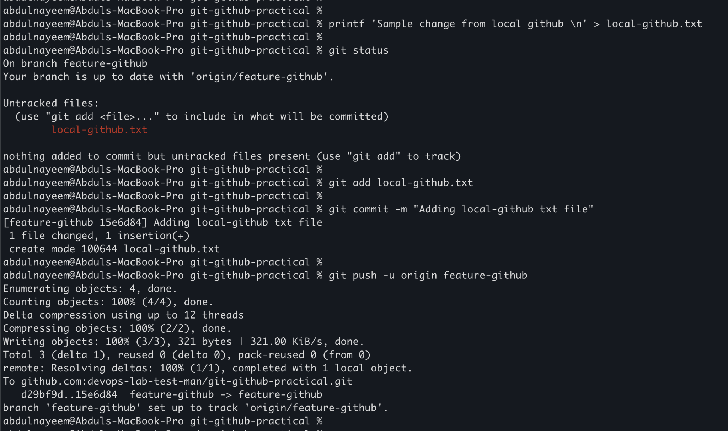
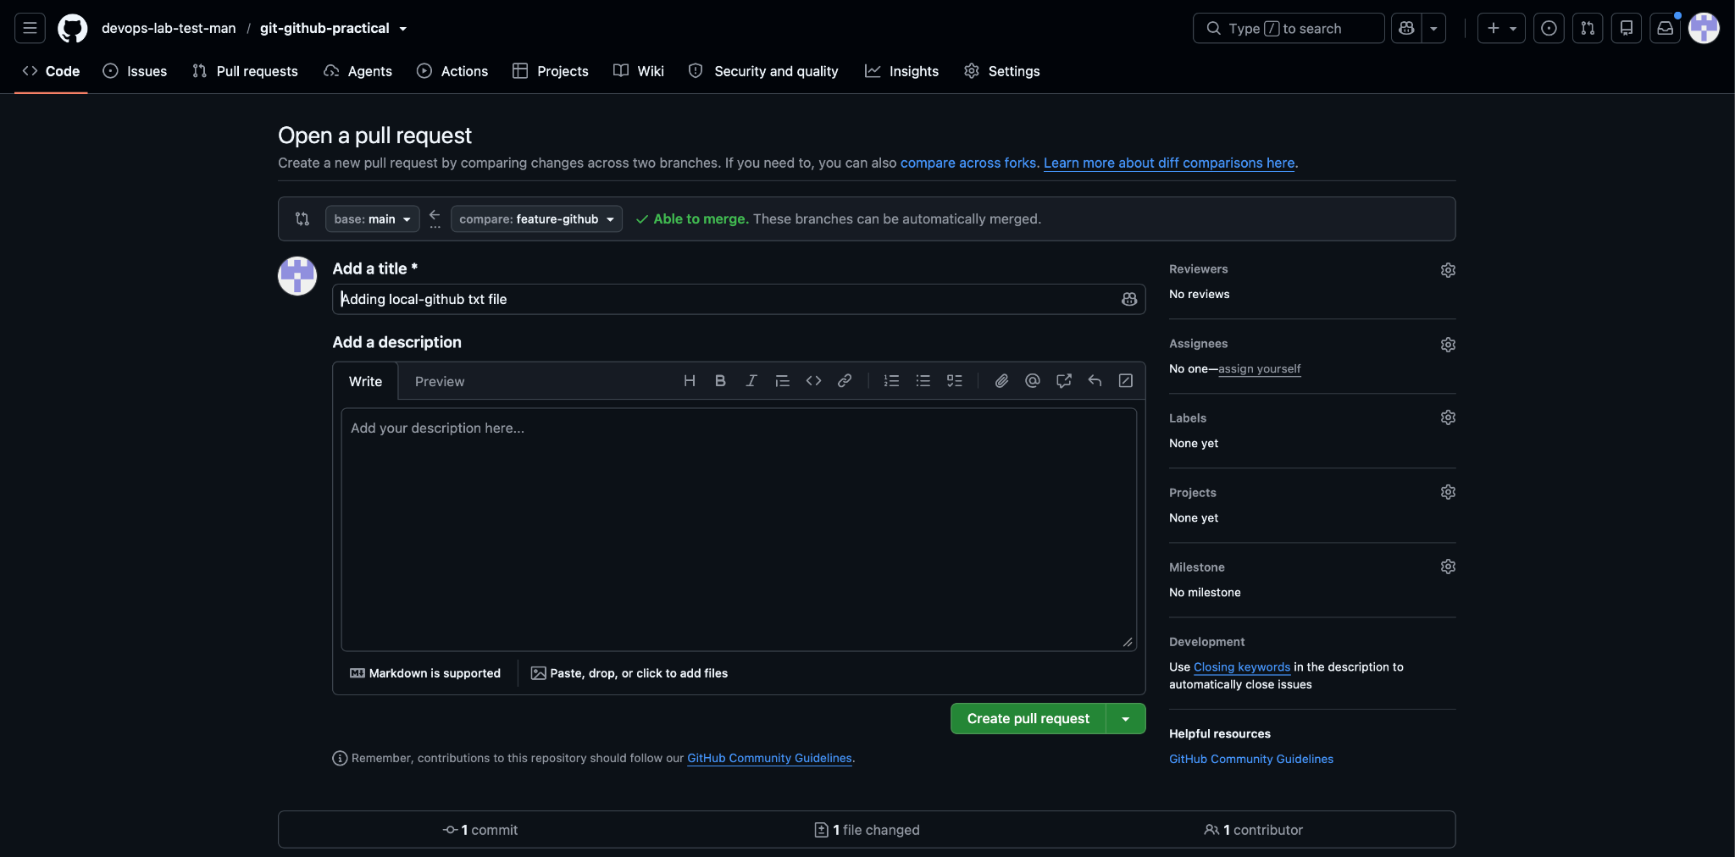
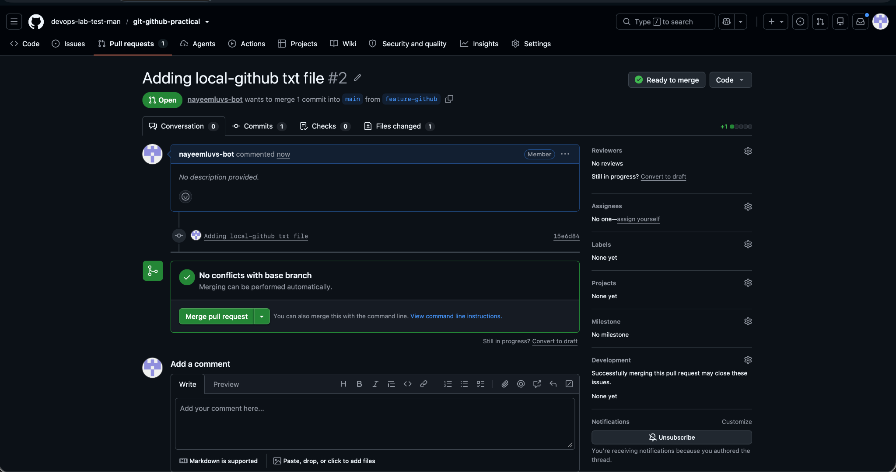
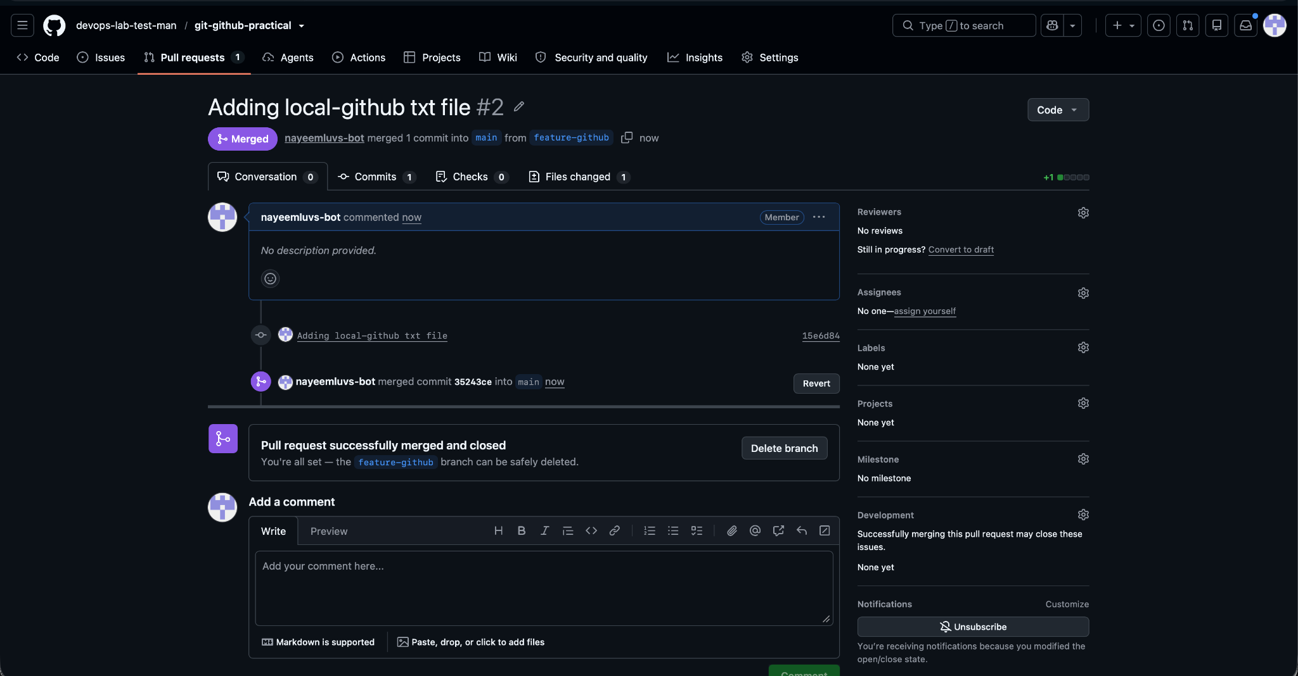

Task 10. Create a File Locally and Send It to a GitHub Branch
Purpose: Add a local change to an existing remote branch and push it.

Steps
- Switch to the target branch, for example `feature-github`.
- Create a new file.
- Stage and commit the file.
- Push the branch to GitHub.

Commands / Actions
git switch feature-github
printf 'File added locally to GitHub branch\n' > branch-file.txt
git add branch-file.txt
git commit -m "Add branch file"
git push origin feature-github

Expected Result
The new file is visible in the selected GitHub branch.
Evidence / Screenshot: Attach the relevant screenshot(s) showing the command/output or GitHub UI result.
- Evidence: Screenshot of the local commit.
- Evidence: Screenshot of the GitHub branch showing `branch-file.txt`.
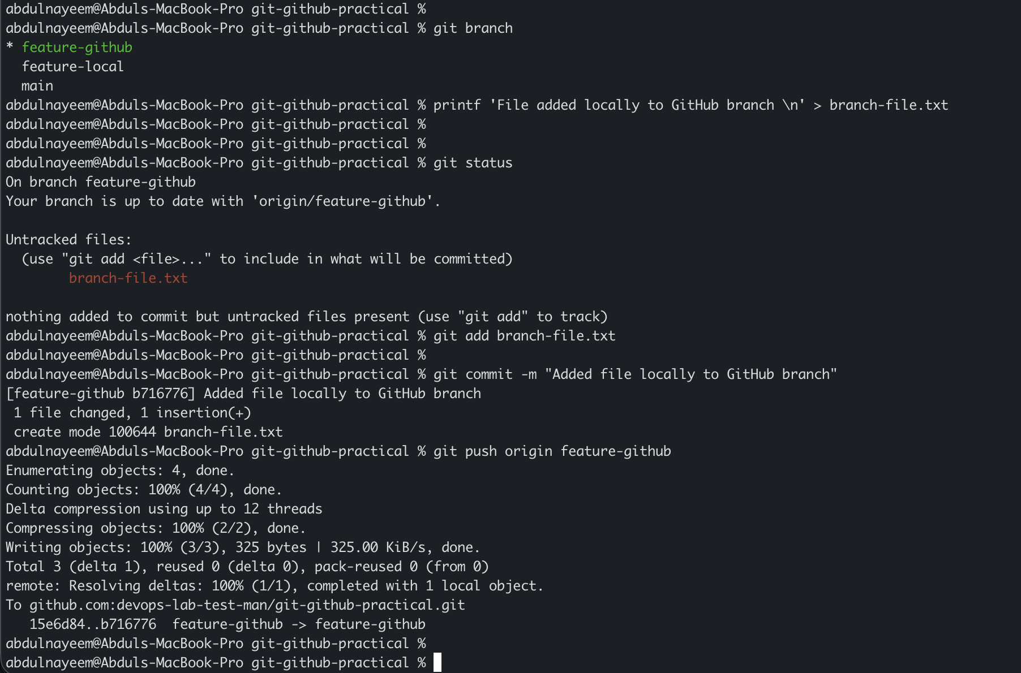
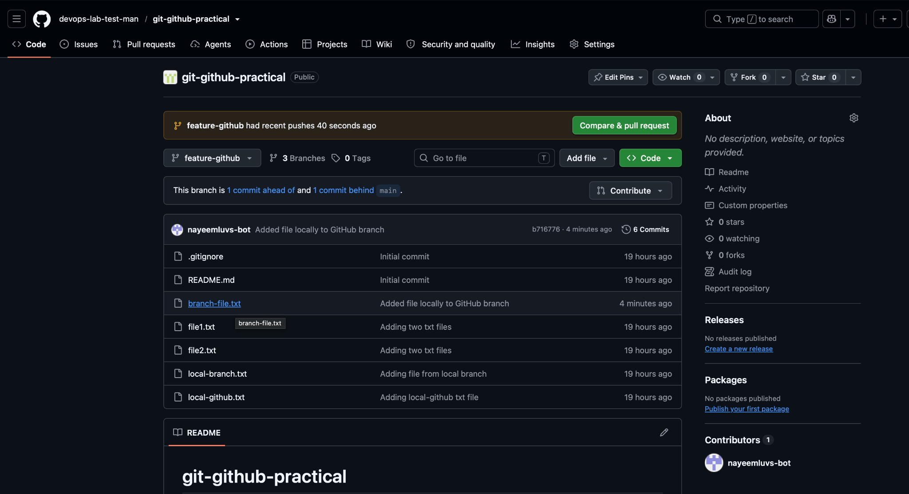

Task 11. Clone Only One Branch from GitHub
Purpose: Clone only the required branch rather than checking out all branches in a normal clone workflow.

Steps
- Use the GitHub clone URL.
- Run `git clone` with the `--branch` and `--single-branch` options.
- Enter the cloned directory and verify the branch.

Commands / Actions
git clone --branch feature-github --single-branch https://github.com/<USERNAME>/git-github-practical.git git-single-branch
cd git-single-branch
git branch --show-current

Expected Result
The local working copy is initialized with the requested branch and its history only.
Evidence / Screenshot: Attach the relevant screenshot(s) showing the command/output or GitHub UI result.
- Evidence: Screenshot of the clone command.
- Evidence: Screenshot of `git branch --show-current` and `git branch -a`.
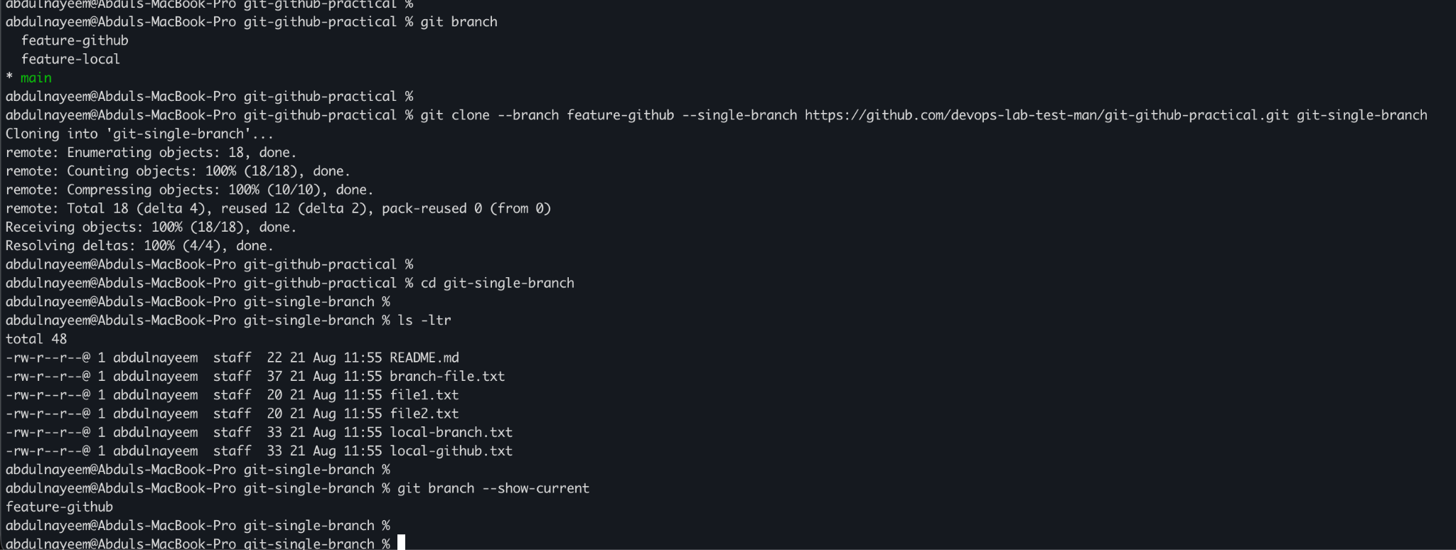

Task 12. Make a Password File Untrackable with Git
Purpose: Prevent sensitive password/secret files from being committed by using `.gitignore`.

Steps
- Create a local file named `passwords.txt` for demonstration only; do not use real credentials.
- Add `passwords.txt` to `.gitignore`.
- Check status to confirm Git does not list the file as an untracked file.
- If a sensitive file was already tracked, remove it from the index with `git rm --cached` and rotate any exposed credentials.

Commands / Actions
printf 'demo_password=DO_NOT_USE_REAL_PASSWORDS\n' > passwords.txt
printf '\n# Local secrets - never commit\npasswords.txt\n*.secret\n.env\n' >> .gitignore
git status
# If it was already tracked: git rm --cached passwords.txt

Expected Result
The password file remains on disk but is ignored by Git and is not shown as an untracked file.
Evidence / Screenshot: Attach the relevant screenshot(s) showing the command/output or GitHub UI result.
- Evidence: Screenshot of `.gitignore` entry.
- Evidence: Screenshot of `git status` confirming `passwords.txt` is ignored/not listed.
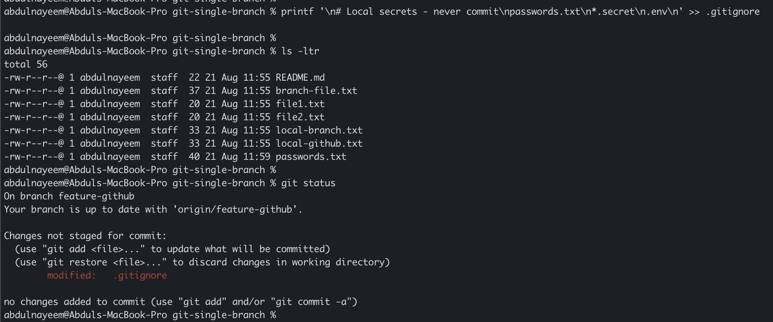
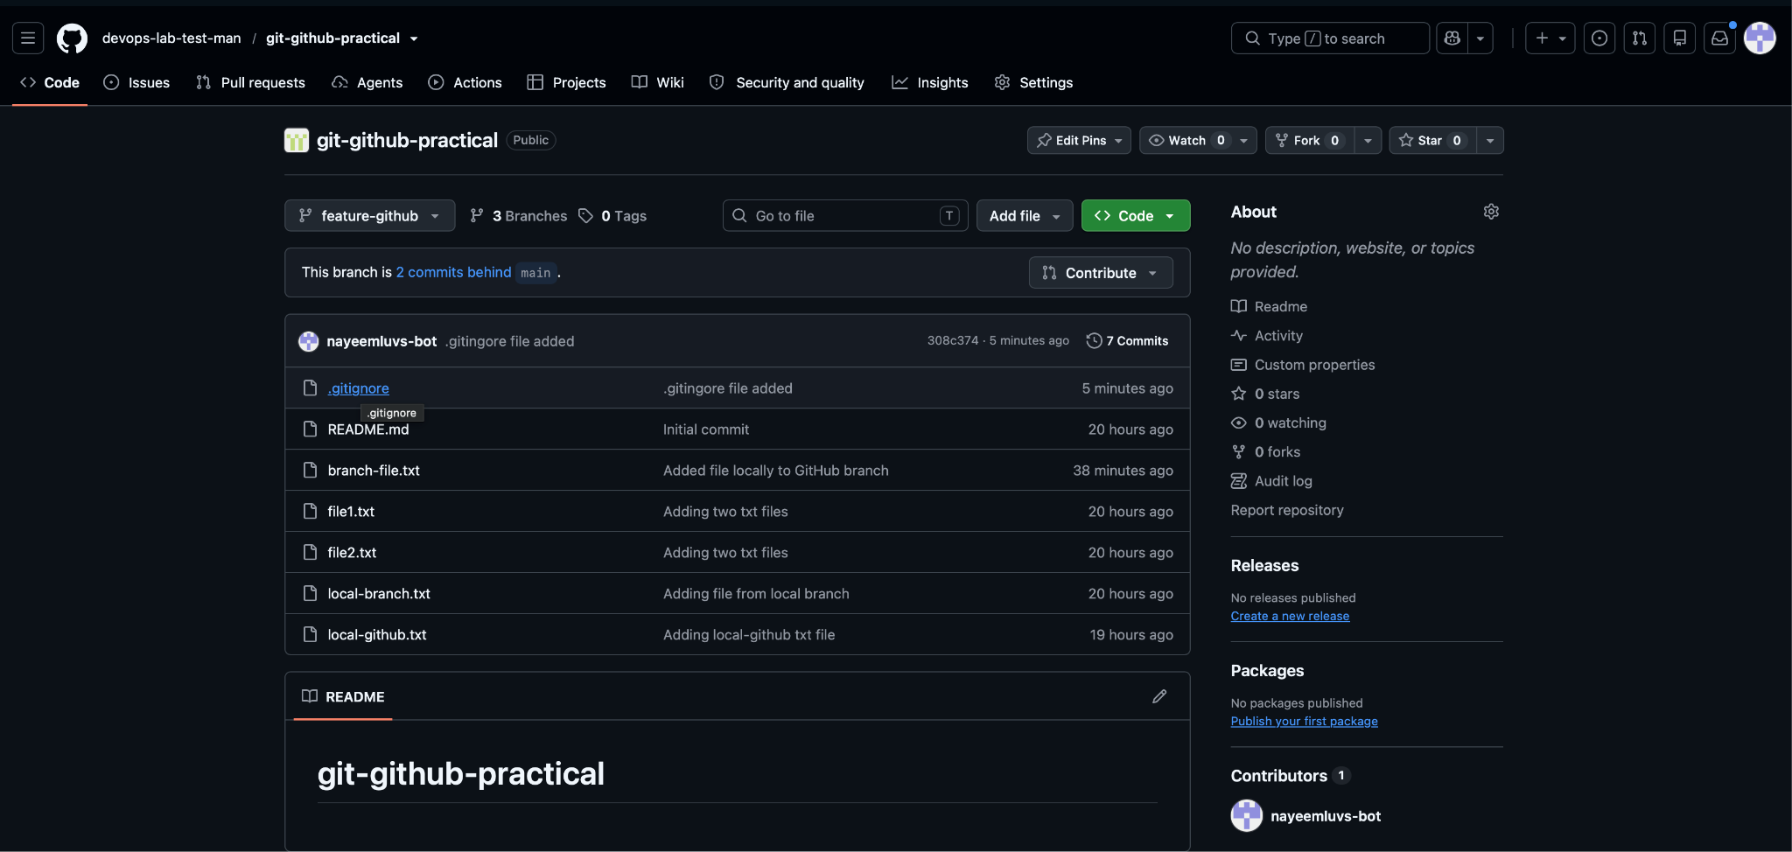

Task 13. Reset a Commit Without Keeping the Commit Changes
Purpose: Demonstrate a hard reset to remove the latest commit and its associated working-tree changes.

Steps
- Create a temporary file and commit it.
- Identify the commit immediately before the temporary commit.
- Run a hard reset to that earlier commit.
- Verify the log and working tree.

Commands / Actions
printf 'Temporary reset example\n' > reset-demo.txt
git add reset-demo.txt && git commit -m "Temporary commit for reset demo"
git log --oneline -3
git reset --hard HEAD~1
git status
git log --oneline -3

Expected Result
The latest commit is removed from the current branch and its uncommitted changes are discarded. Use this only for commits that have not been shared or when you understand the impact.
Evidence / Screenshot: Attach the relevant screenshot(s) showing the command/output or GitHub UI result.
- Evidence: Screenshot before reset showing the temporary commit.
- Evidence: Screenshot after `git reset --hard` showing the commit removed.
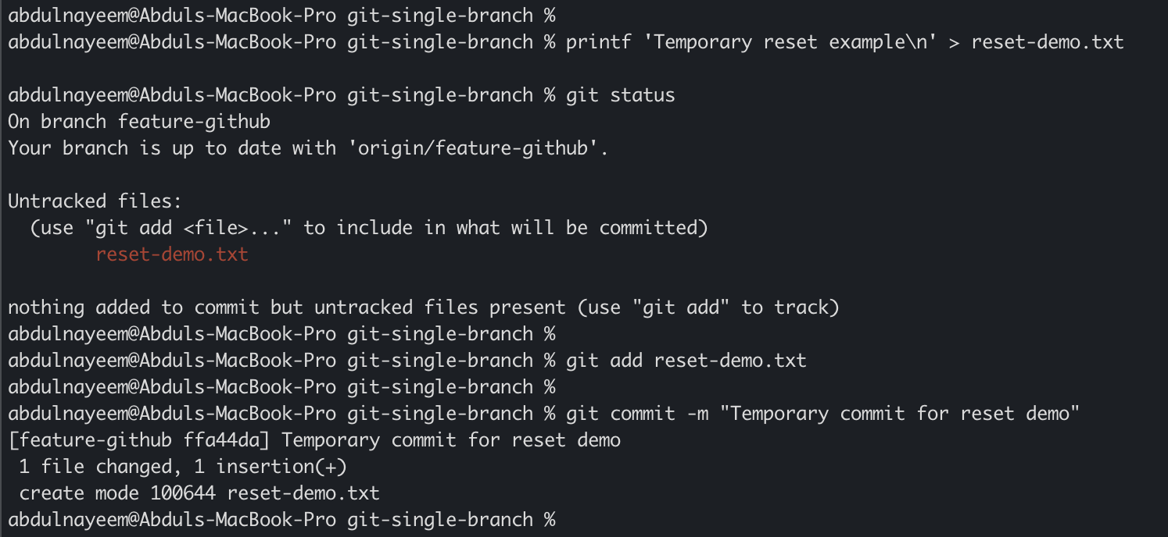
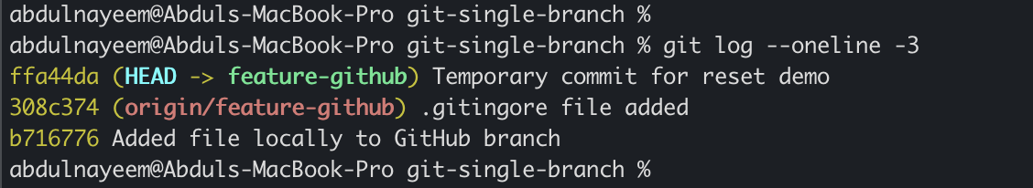
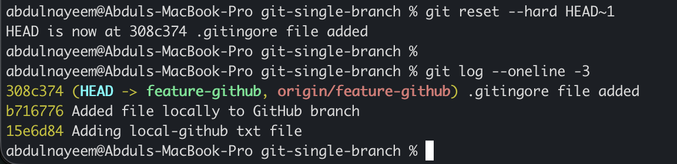

Task 14. Revert a Committed Commit to the Older Version
Purpose: Undo a shared commit safely by creating a new inverse commit.

Steps
- Identify the commit to undo.
- Run `git revert` using the commit hash.
- Resolve conflicts if prompted, then complete the revert.
- Push the new revert commit.

Commands / Actions
git log --oneline -5
git revert <COMMIT_HASH>
git log --oneline -5
git push origin main

Expected Result
A new revert commit is created and the repository content is restored to the state before the selected commit.
Evidence / Screenshot: Attach the relevant screenshot(s) showing the command/output or GitHub UI result.
- Evidence: Screenshot showing the original commit and the new revert commit.
- Evidence: Screenshot of the pushed revert commit on GitHub.
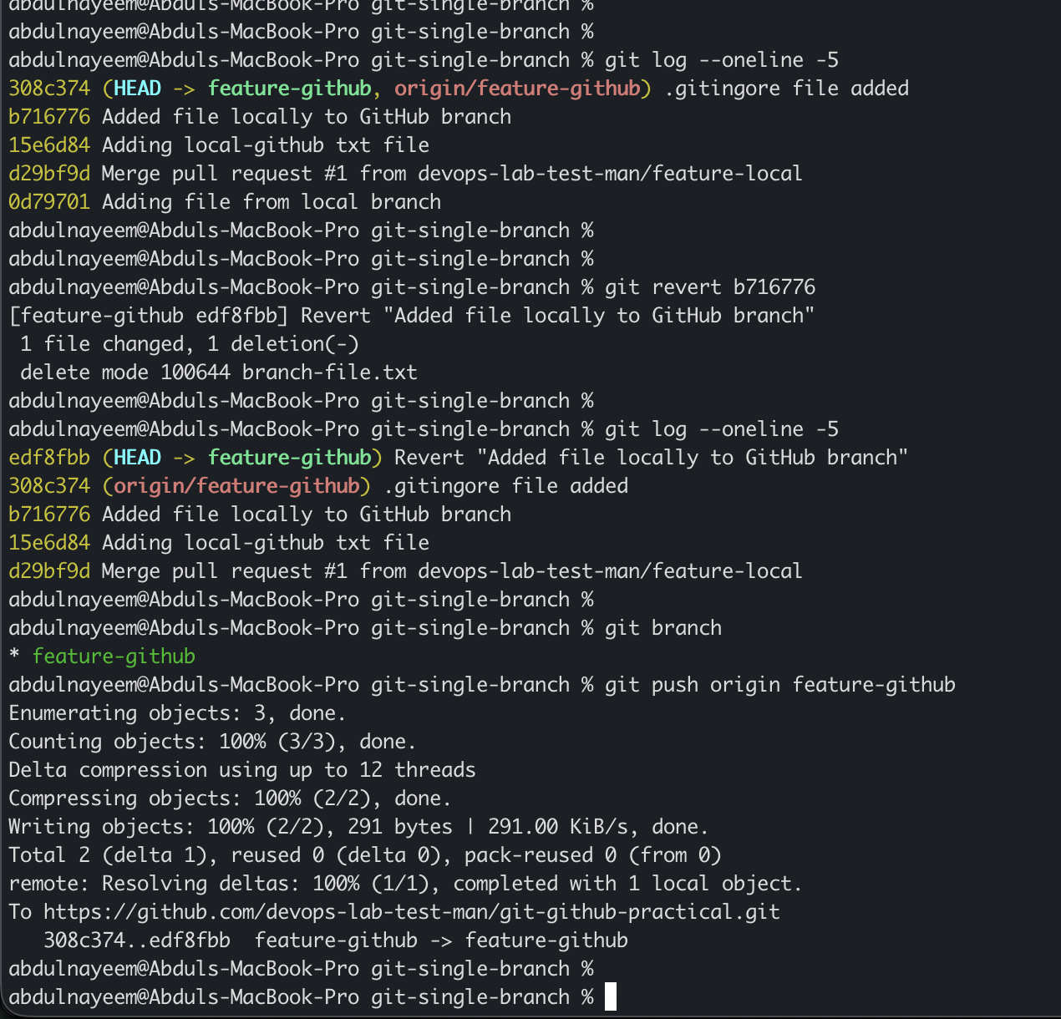

Task 15. Stash Changes and Work on Another File
Purpose: Temporarily store uncommitted work without committing it, then continue with another task.

Steps
- Modify/create a file without committing it.
- Check status and stash the work.
- Create or modify a different file.
- Commit the independent change if appropriate.

Commands / Actions
printf 'Work in progress\n' >> stash-demo.txt
git status
git stash
git status
printf 'Independent work\n' > another-file.txt
git add another-file.txt && git commit -m "Add independent work"
git stash list

Expected Result
The first change is stored in the stash while the second file can be worked on independently.
Evidence / Screenshot: Attach the relevant screenshot(s) showing the command/output or GitHub UI result.
- Evidence: Screenshot before stash.
- Evidence: Screenshot of `git stash list`.
- Evidence: Screenshot showing the independent commit.
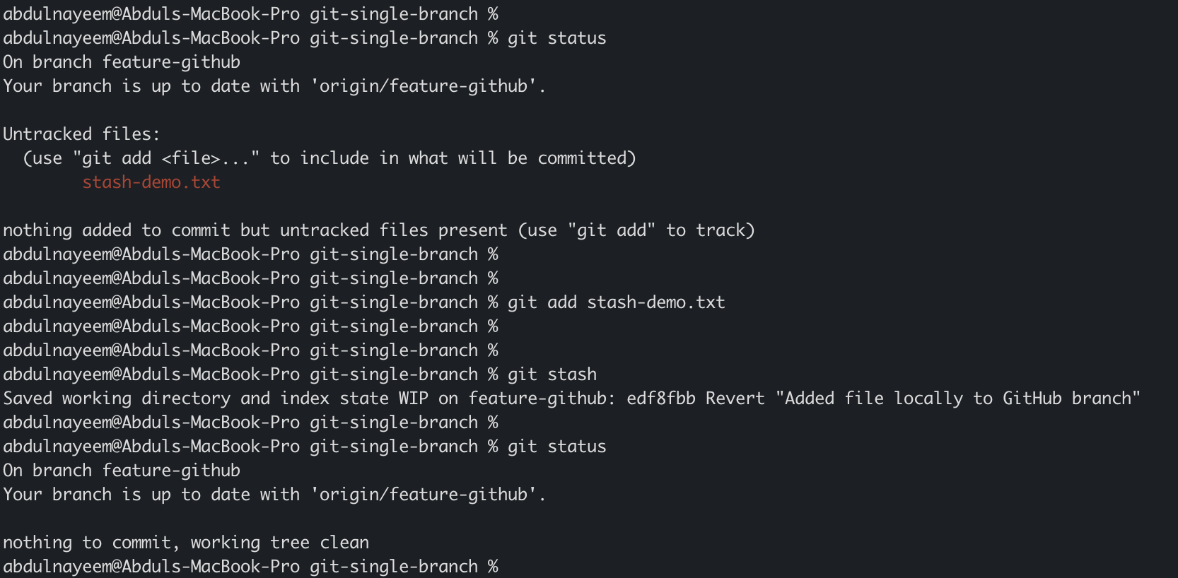
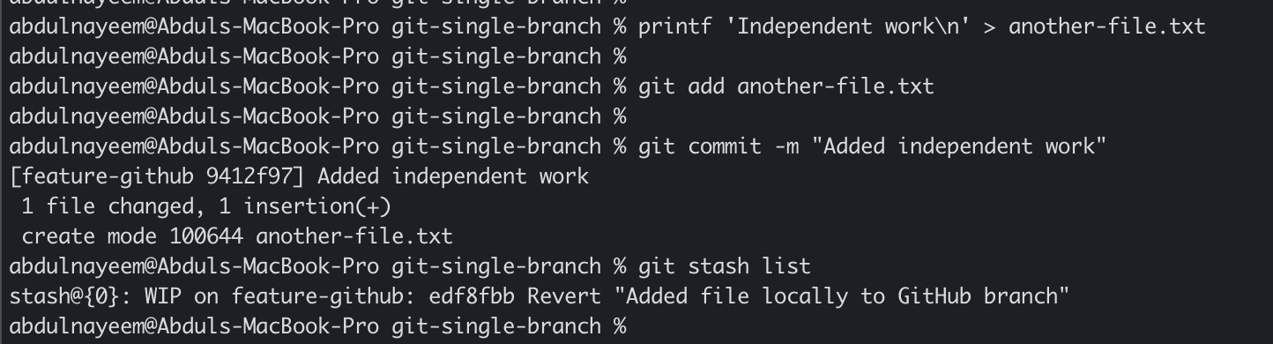
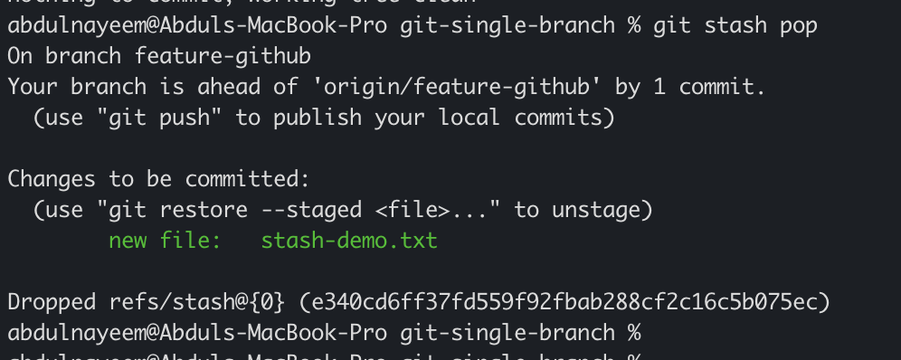

Task 16. Apply the Stashed Work and Continue Working
Purpose: Restore the previously stashed changes to the working tree.

Steps
- List available stashes.
- Apply the required stash.
- Verify the restored file and continue editing it.
- Commit when the work is complete, if required.

Commands / Actions
git stash list
git stash pop
git status
cat stash-demo.txt

Expected Result
The stashed changes are restored to the working tree. If `git stash apply` is used instead, the stash remains until explicitly dropped.
Evidence / Screenshot: Attach the relevant screenshot(s) showing the command/output or GitHub UI result.
- Evidence: Screenshot of `git stash pop` output.
- Evidence: Screenshot of restored file content and `git status`.
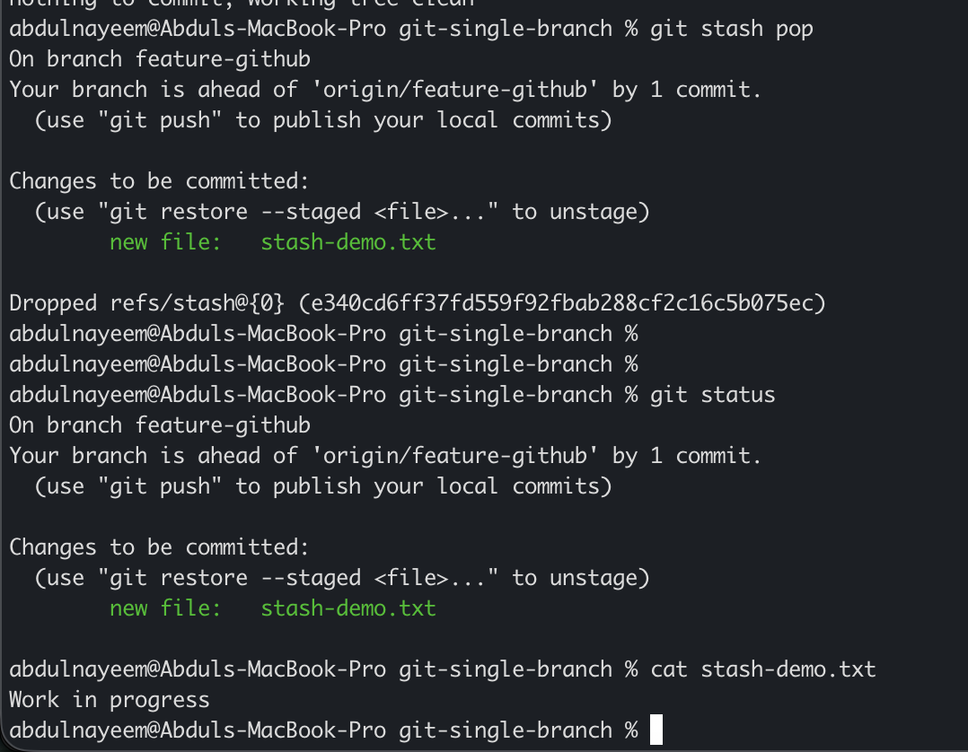

Task 17. Generate SSH Key and Configure GitHub
Purpose: Configure passwordless SSH authentication for Git operations.

Steps
- Generate an ED25519 SSH key pair using a passphrase.
- Start the SSH agent and add the private key.
- Copy the public key.
- In GitHub, open Settings → SSH and GPG keys → New SSH key and paste the public key.
- Test authentication.
- Optionally change the repository remote from HTTPS to SSH.

Commands / Actions
ssh-keygen -t ed25519 -C "your_email@example.com"
eval "$(ssh-agent -s)"
ssh-add ~/.ssh/id_ed25519
cat ~/.ssh/id_ed25519.pub
ssh -T git@github.com
git remote set-url origin git@github.com:<USERNAME>/git-github-practical.git
git remote -v

Expected Result
GitHub authenticates the SSH key and the repository remote uses the SSH URL if changed.
Evidence / Screenshot: Attach the relevant screenshot(s) showing the command/output or GitHub UI result.
- Evidence: Screenshot of key generation (do not expose the private key).
- Evidence: Screenshot of GitHub SSH key entry.
- Evidence: Screenshot of successful `ssh -T git@github.com`.
- Evidence: Screenshot of `git remote -v`.
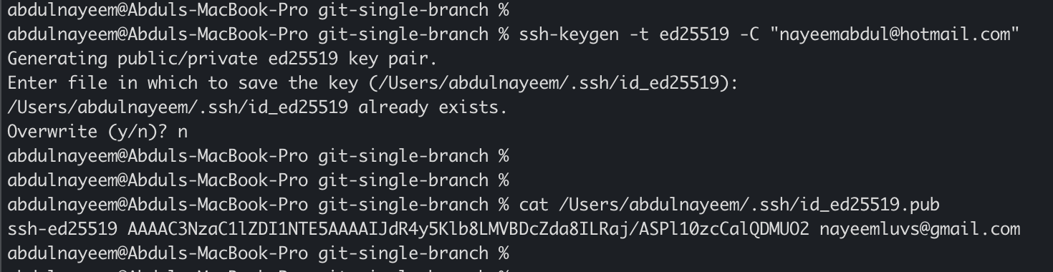
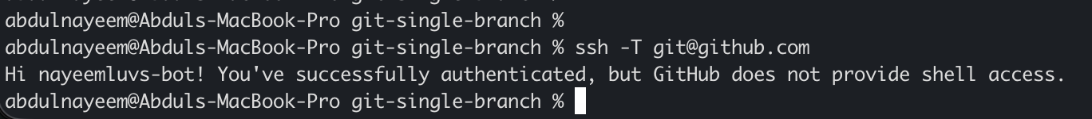
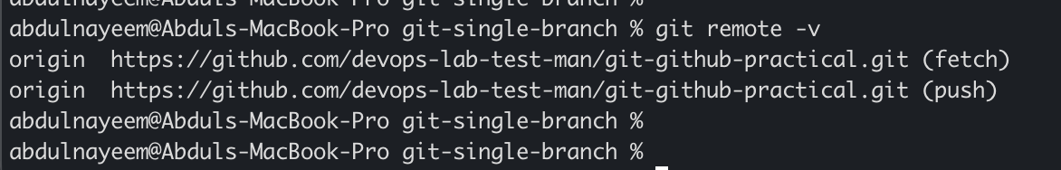

Task 18. Configure a GitHub Webhook
Purpose: Configure GitHub to notify an external system when repository events occur.

Steps
- Prepare an approved webhook receiver URL that can receive POST requests.
- Open the repository on GitHub → Settings → Webhooks → Add webhook.
- Enter the Payload URL.
- Select `application/json` and choose the required events, such as push events.
- Save the webhook.
- Trigger a test event by pushing a non-sensitive change and verify delivery status.

Commands / Actions
GitHub UI: Repository → Settings → Webhooks → Add webhook → Payload URL → Content type: application/json → Events → Add webhook.
git switch main
printf 'Webhook test\n' > webhook-test.txt
git add webhook-test.txt && git commit -m "Test GitHub webhook"
git push origin main

Expected Result
GitHub shows the webhook as active and a successful delivery response from the receiver.
Evidence / Screenshot: Attach the relevant screenshot(s) showing the command/output or GitHub UI result.
- Evidence: Screenshot of webhook configuration (hide tokens/secrets).
- Evidence: Screenshot of recent webhook delivery with successful response/status.
- Evidence: Screenshot of the push that triggered the webhook.
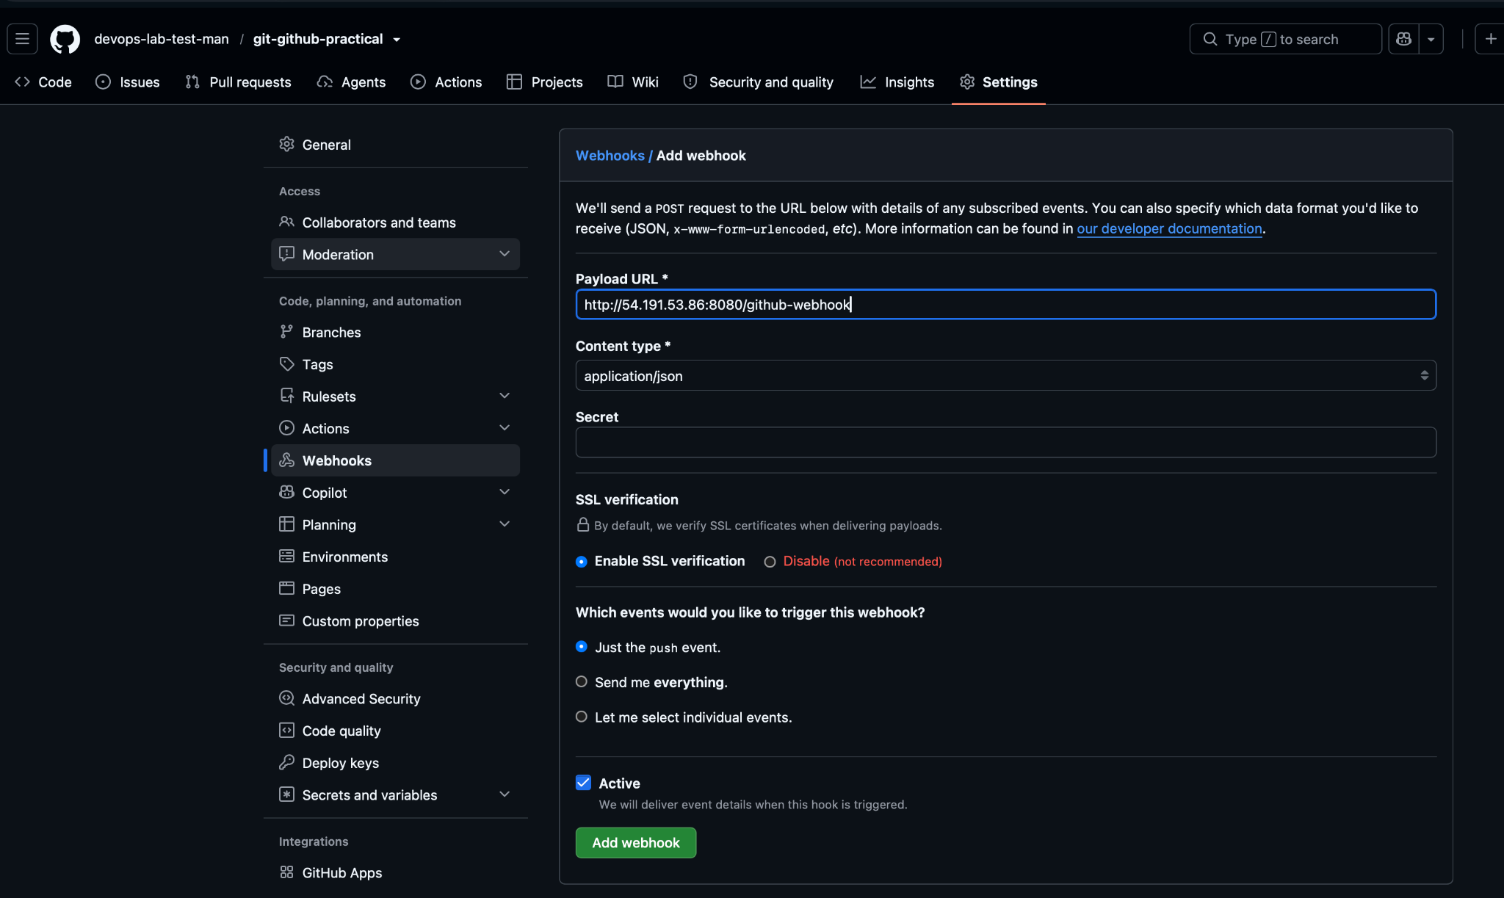
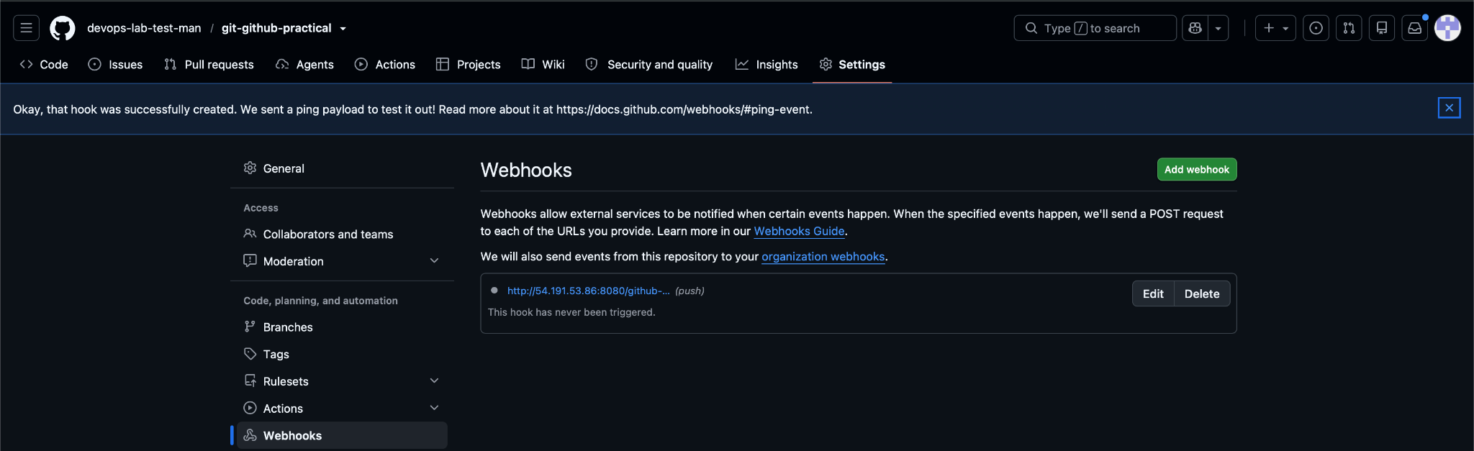
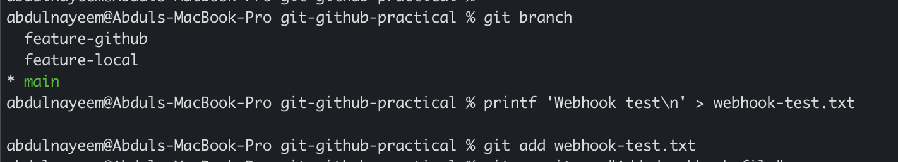
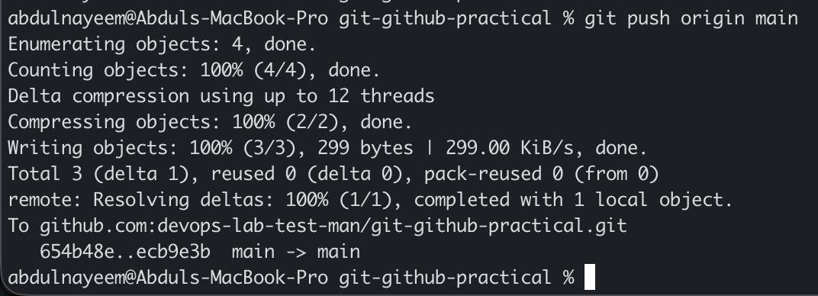

Task 19. Basic Understanding of the .git Directory
Purpose: Inspect the local Git metadata and understand the purpose of its major components.

Steps
- Run `ls -la` to show the hidden `.git` directory.
- Inspect safe metadata such as config, HEAD and refs.
- Do not manually edit internal object files unless you understand Git internals.
- Explain that `.git` contains repository metadata, objects, references, logs and configuration.

Commands / Actions
ls -la
git rev-parse --git-dir
git status
cat .git/HEAD
cat .git/config
find .git/refs -maxdepth 2 -type f -print

Expected Result
The `.git` directory is visible and its metadata can be inspected. The working files are separate from the Git database/metadata.
Evidence / Screenshot: Attach the relevant screenshot(s) showing the command/output or GitHub UI result.
- Evidence: Screenshot of `ls -la` showing `.git`.
- Evidence: Screenshot of `.git/HEAD` and `.git/config` output.
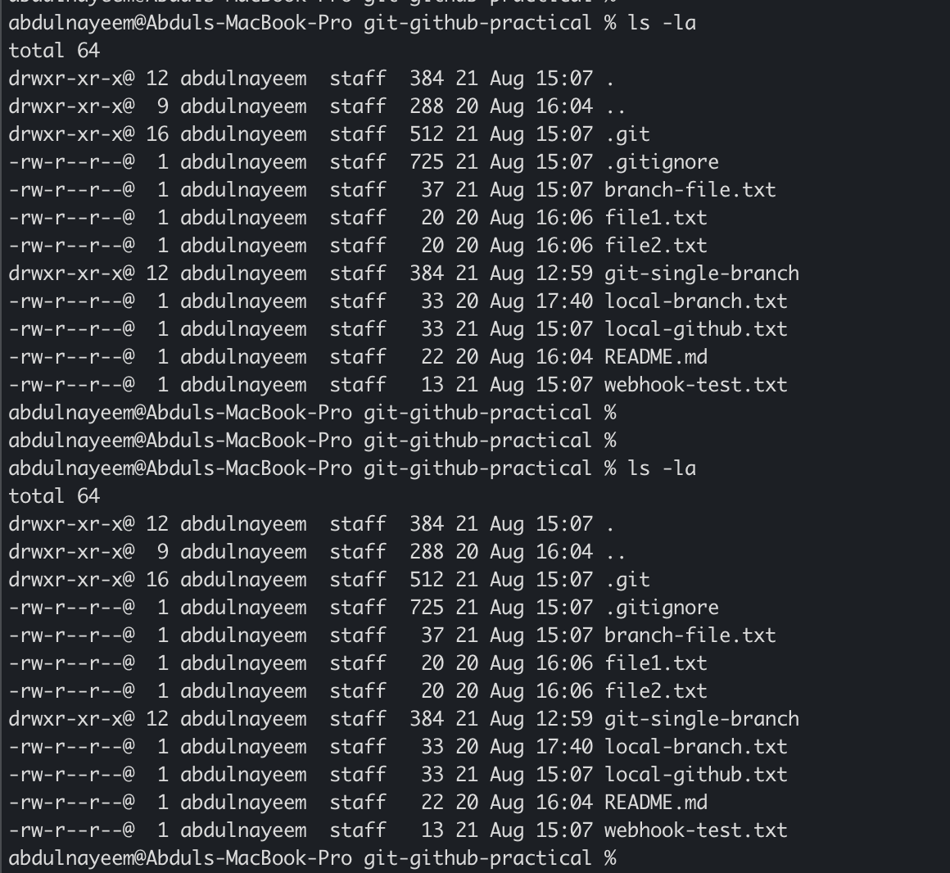
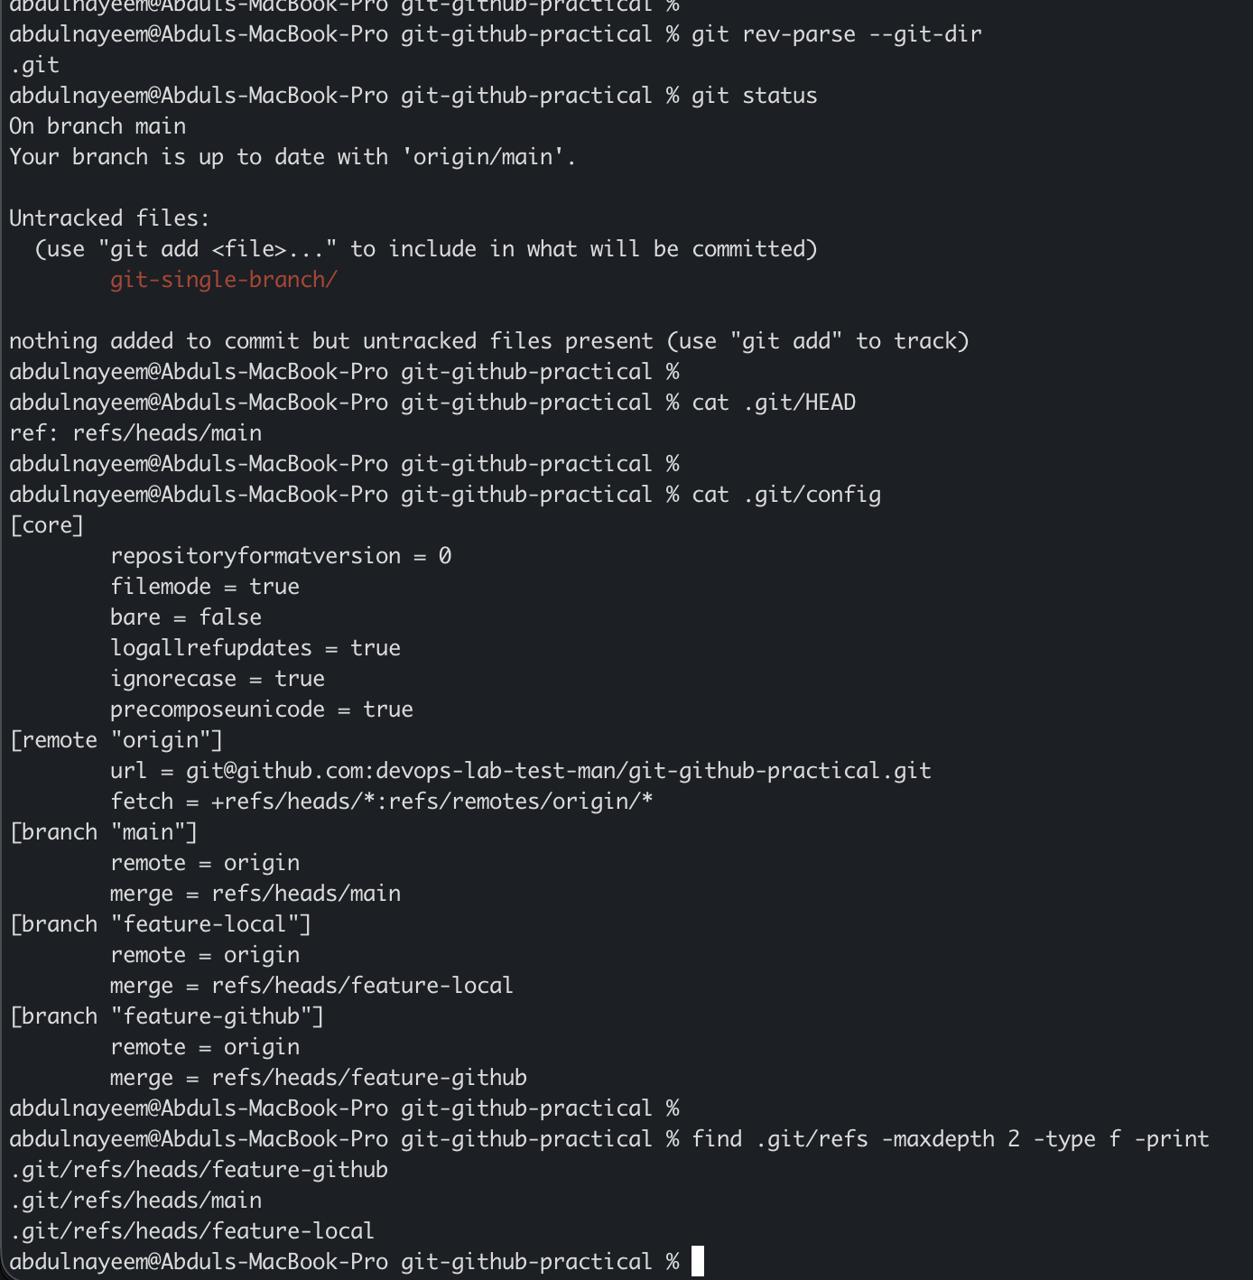

Task 20. Check All Git Logs
Purpose: Inspect commit history and understand different log views.

Steps
- View the standard commit history.
- View a compact history.
- View an ASCII graph with branches and tags.
- Inspect details of a specific commit.

Commands / Actions
git log
git log --oneline
git log --oneline --graph --decorate --all
git show <COMMIT_HASH>

Expected Result
The terminal displays commit history, branch relationships and commit details.
Evidence / Screenshot: Attach the relevant screenshot(s) showing the command/output or GitHub UI result.
- Evidence: Screenshot of `git log --oneline --graph --decorate --all`.
- Evidence: Screenshot of `git show` for a selected commit.
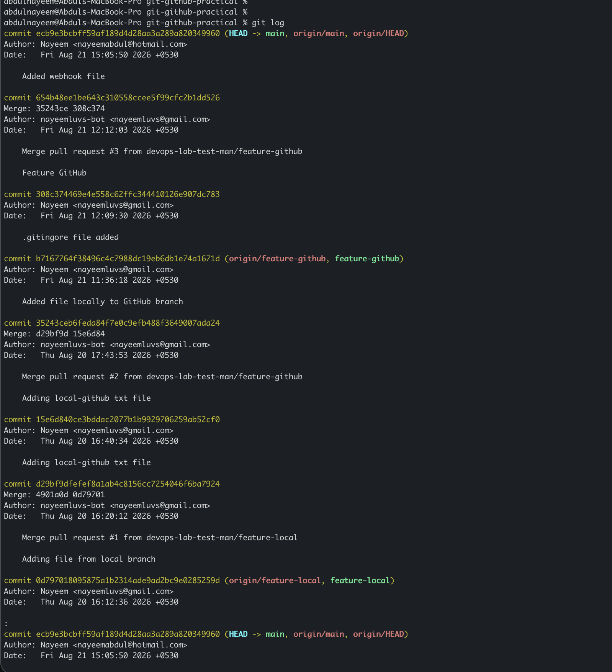
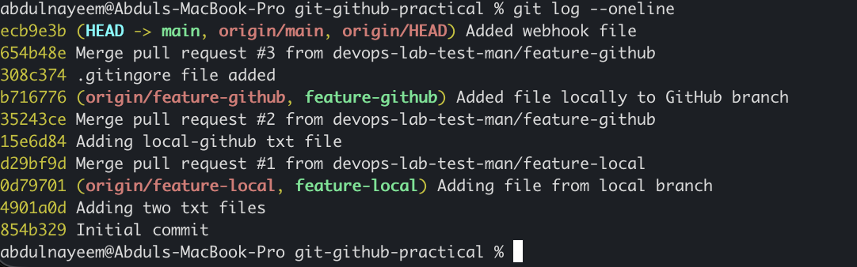
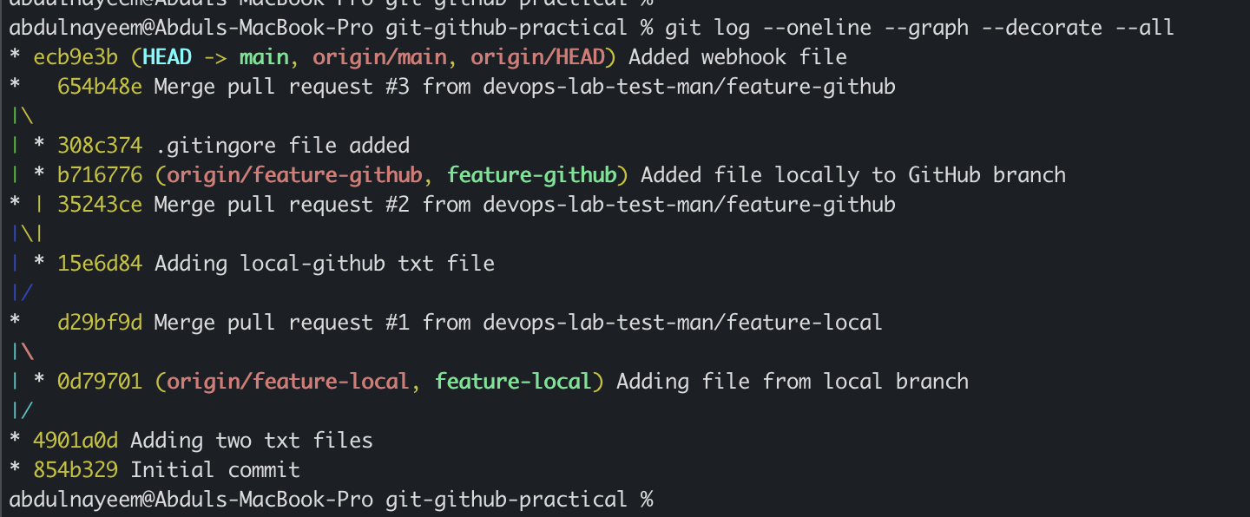
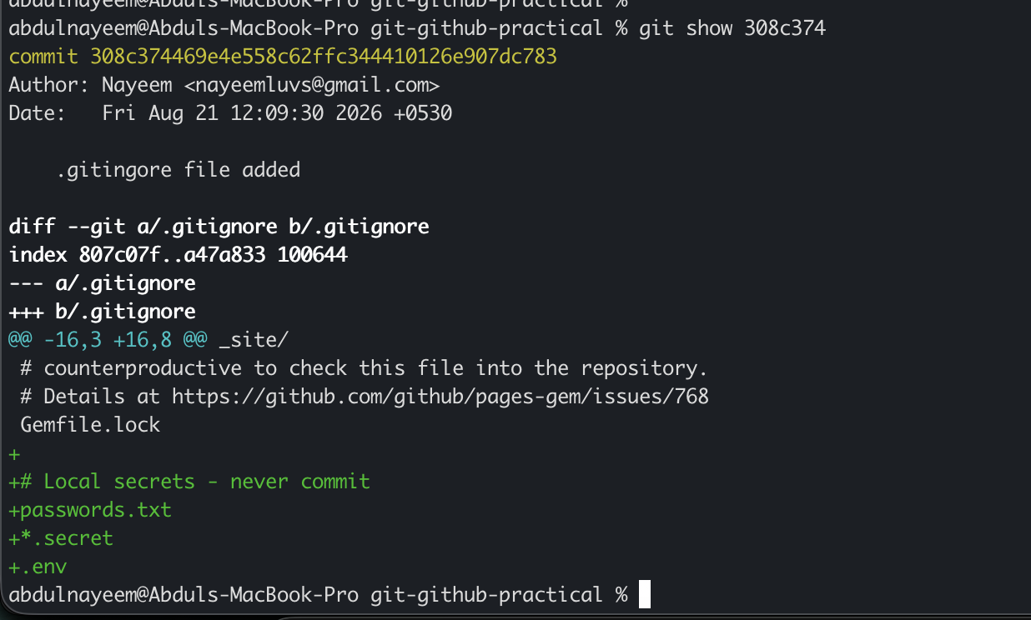

Task 21. Rename a Commit Message
Purpose: Correct or improve the latest local commit message.

Steps
- Ensure the commit is the latest commit.
- Amend its message.
- Verify the updated message.
- If the commit was already pushed, understand that amending changes its commit ID and may require a safe force push depending on branch policy.

Commands / Actions
git commit --amend -m "Corrected commit message"
git log -1 --oneline

Expected Result
The latest commit has the new message. Avoid rewriting shared history unless your team workflow explicitly permits it.
Evidence / Screenshot: Attach the relevant screenshot(s) showing the command/output or GitHub UI result.
- Evidence: Screenshot of the amended commit and updated `git log -1 --oneline`.
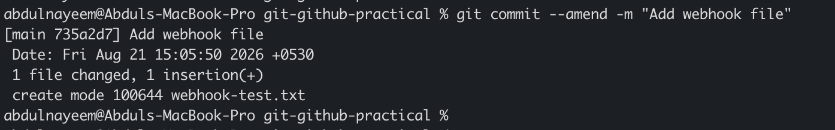

Task 22. Merge Multiple Commits into a Single Commit
Purpose: Squash several local commits into one clean commit before sharing or merging.

Steps
- Create at least three small local commits for the demonstration.
- Start an interactive rebase for the desired number of commits.
- Keep the first commit as `pick` and change subsequent commits to `squash` or `fixup`.
- Edit the final combined commit message.
- Verify the history.

Commands / Actions
git log --oneline -5
git rebase -i HEAD~3
# In the editor: keep the first line as 'pick'; change the next two to 'squash' or 'fixup'.
git log --oneline -5

Expected Result
Multiple local commits are combined into one commit. If those commits were already pushed, coordinate carefully because history rewriting can require a force push.
Evidence / Screenshot: Attach the relevant screenshot(s) showing the command/output or GitHub UI result.
- Evidence: Screenshot of the interactive rebase screen showing `pick`/`squash`.
- Evidence: Screenshot of the final log showing the single squashed commit.
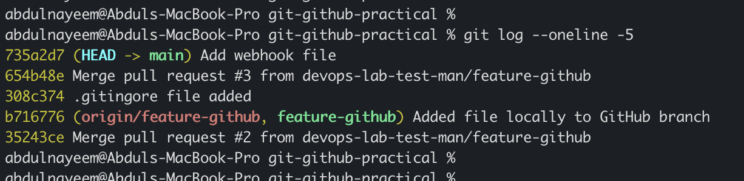
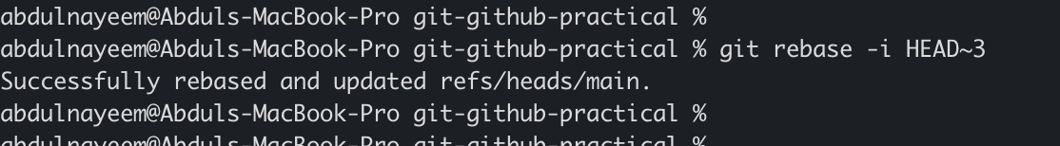
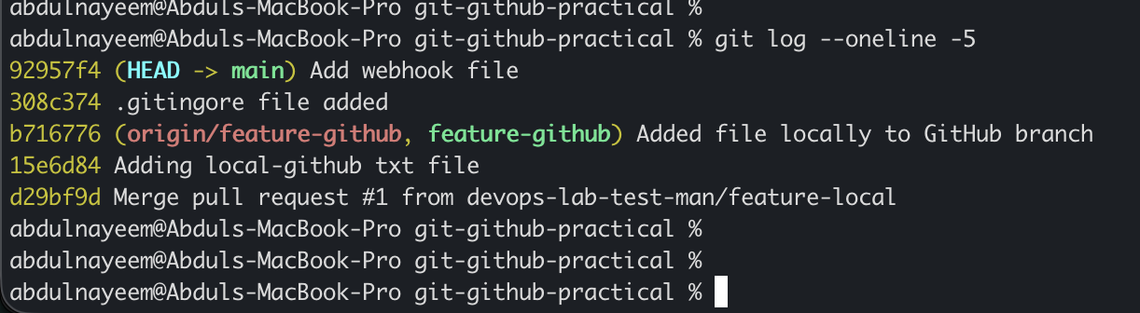

4. Evidence Submission Checklist
Capture screenshots at each major milestone. Screenshots should clearly show the command, terminal prompt/repository, or GitHub page and result. Do not include private SSH keys, passwords, access tokens, webhook secrets or other credentials.
- ☐ Git installation and version
- ☐ GitHub repository with README.md and .gitignore
- ☐ Successful local clone and remote configuration
- ☐ Two local files created and visible in git status
- ☐ Commit and push of two files
- ☐ Local feature branch and successful push
- ☐ GitHub-created branch tracked locally
- ☐ Local branch merge into main
- ☐ GitHub Pull Request created and merged
- ☐ Local file pushed to a GitHub branch
- ☐ Single-branch clone
- ☐ Password file ignored using .gitignore
- ☐ Hard reset demonstration
- ☐ Revert commit demonstration
- ☐ Stash demonstration
- ☐ Stash restoration demonstration
- ☐ SSH key configured and authentication verified
- ☐ GitHub webhook configuration and successful delivery
- ☐ .git directory inspection
- ☐ Git logs
- ☐ Commit message amendment
- ☐ Interactive rebase/squash

5. Recommended Screenshot Naming Convention
01_git_install.png
02_github_repo.png
03_clone.png
...
22_squash_commits.png
For final submission, place the screenshots in the corresponding task sections or append them after the task description. Use clear filenames so the reviewer can map each screenshot to the assigned task.

6. Important Git Safety Notes
- Never commit real passwords, API keys, private SSH keys, access tokens or production secrets.
- A `.gitignore` rule prevents untracked files from being added, but it does not remove secrets already committed. Rotate exposed credentials and remove them from repository history when necessary.
- `git reset --hard` discards working-tree changes. Use it only when you intentionally want to lose those changes.
- `git revert` is generally safer for shared branches because it creates a new commit instead of rewriting existing shared history.
- Amending commits, interactive rebase and force-pushing can rewrite history. Avoid rewriting protected/shared branches unless the team workflow explicitly allows it.
- For SSH evidence, show only the public key and authentication result; never screenshot or paste the private key.
- For webhook evidence, hide secrets, signing tokens and sensitive request payloads.

7. Final Completion Sign-off
Candidate Name | ____________________________________________
Repository URL | ____________________________________________
All 22 Tasks Completed | Yes / No
Reviewer / Trainer Signature | ____________________________________________

